***LAKME 230***

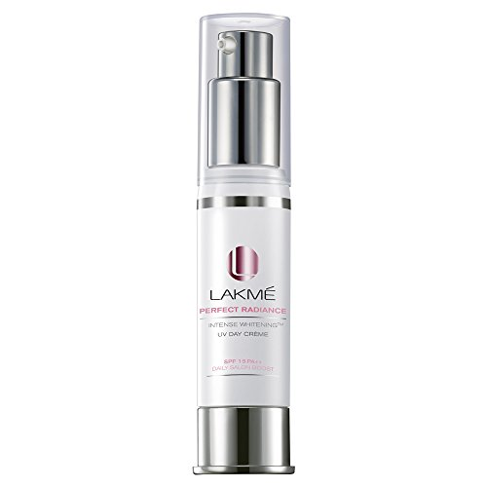

***DESCRIPTION:***

**LAKME’S LIPGLOSS IS 100% PURE.IT CONTAIN VITAMIN-E.IT PROVIDE IN VARIOUS TYPES OF COLOR.IT GENTLY CLEANESS AND MOISTURIZES YOUR LIPS,KEEPING IT SOFT AND GLOWING.WHEN SOMEONE USE THERE LIPS MUST LOOKS VERY SHINY.**